**East West University**

**Course title: Database Systems**

**Course code: CSE302**

**Spring 2022**

**Section: 6**

**Wholesale management system**

**Submitted To:**

**Dr. Md Anisur Rahman**

Professor,

Department of Computer Science and Engineering

Khulna University, Khulna

**Submitted By:**

|  |  |
| --- | --- |
| **Mysha Maliha Priyanka** | 2020-1-60-230 |
| **K. M. Safin Kamal** | 2020-1-60-235 |
| **Md.Hasibur Rahman** | 2020-1-60-068 |
| **Md.Arash kursy Sourov** | 2020-1-60-177 |

Department of Computer Science and Engineering

East West University, Dhaka

Date of Submission: 27/ 03 / 2022

**Diagram:**

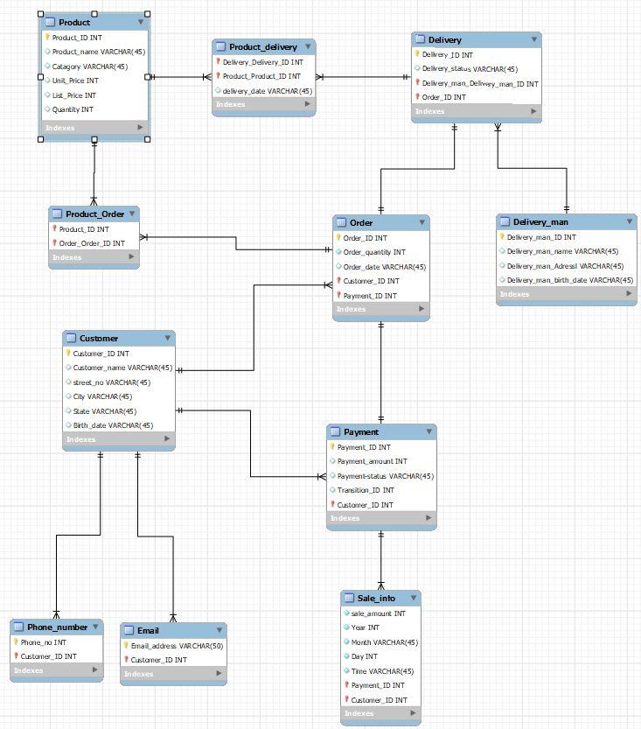

-- MySQL Workbench Forward Engineering

SET @OLD_UNIQUE_CHECKS=@@UNIQUE_CHECKS, UNIQUE_CHECKS=0;

SET @OLD_FOREIGN_KEY_CHECKS=@@FOREIGN_KEY_CHECKS, FOREIGN_KEY_CHECKS=0;

SET @OLD_SQL_MODE=@@SQL_MODE, SQL_MODE='ONLY_FULL_GROUP_BY,STRICT_TRANS_TABLES,NO_ZERO_IN_DATE,NO_ZERO_DATE,ERROR_FOR_DIVISION_BY_ZERO,NO_ENGINE_SUBSTITUTION';

-- -----------------------------------------------------

-- Schema mydb

-- -----------------------------------------------------

-- -----------------------------------------------------

-- Schema mydb

-- -----------------------------------------------------

CREATE SCHEMA IF NOT EXISTS `mydb` DEFAULT CHARACTER SET utf8 ;

USE `mydb` ;

-- -----------------------------------------------------

-- Table `mydb`.`Customer`

-- -----------------------------------------------------

CREATE TABLE IF NOT EXISTS `mydb`.`Customer` (

`Customer_ID` INT NOT NULL,

`Customer_name` VARCHAR(45) NULL,

`street_no` VARCHAR(45) NULL,

`City` VARCHAR(45) NULL,

`State` VARCHAR(45) NULL,

`Birth_date` VARCHAR(45) NULL,

PRIMARY KEY (`Customer_ID`))

ENGINE = InnoDB;

-- -----------------------------------------------------

-- Table `mydb`.`Phone_number`

-- -----------------------------------------------------

CREATE TABLE IF NOT EXISTS `mydb`.`Phone_number` (

`Phone_no` INT NOT NULL,

`Customer_ID` INT NOT NULL,

PRIMARY KEY (`Phone_no`, `Customer_ID`),

INDEX `fk_Phone_number_Customer_idx` (`Customer_ID` ASC) VISIBLE,

CONSTRAINT `fk_Phone_number_Customer`

FOREIGN KEY (`Customer_ID`)

REFERENCES `mydb`.`Customer` (`Customer_ID`)

ON DELETE NO ACTION

ON UPDATE NO ACTION)

ENGINE = InnoDB;

-- -----------------------------------------------------

-- Table `mydb`.`Email`

-- -----------------------------------------------------

CREATE TABLE IF NOT EXISTS `mydb`.`Email` (

`Email_address` VARCHAR(50) NOT NULL,

`Customer_ID` INT NOT NULL,

PRIMARY KEY (`Email_address`, `Customer_ID`),

INDEX `fk_Email_Customer1_idx` (`Customer_ID` ASC) VISIBLE,

CONSTRAINT `fk_Email_Customer1`

FOREIGN KEY (`Customer_ID`)

REFERENCES `mydb`.`Customer` (`Customer_ID`)

ON DELETE NO ACTION

ON UPDATE NO ACTION)

ENGINE = InnoDB;

-- -----------------------------------------------------

-- Table `mydb`.`Payment`

-- -----------------------------------------------------

CREATE TABLE IF NOT EXISTS `mydb`.`Payment` (

`Payment_ID` INT NOT NULL,

`Payment_amount` INT NULL,

`Payment-status` VARCHAR(45) NULL,

`Transition_ID` INT NULL,

`Customer_ID` INT NOT NULL,

PRIMARY KEY (`Payment_ID`, `Customer_ID`),

INDEX `fk_Payment_Customer1_idx` (`Customer_ID` ASC) VISIBLE,

CONSTRAINT `fk_Payment_Customer1`

FOREIGN KEY (`Customer_ID`)

REFERENCES `mydb`.`Customer` (`Customer_ID`)

ON DELETE NO ACTION

ON UPDATE NO ACTION)

ENGINE = InnoDB;

-- -----------------------------------------------------

-- Table `mydb`.`Order`

-- -----------------------------------------------------

CREATE TABLE IF NOT EXISTS `mydb`.`Order` (

`Order_ID` INT NOT NULL,

`Order_quantity` INT NOT NULL,

`Order_date` VARCHAR(45) NULL,

`Customer_ID` INT NOT NULL,

`Payment_ID` INT NOT NULL,

PRIMARY KEY (`Order_ID`, `Customer_ID`, `Payment_ID`),

INDEX `fk_Order_Customer1_idx` (`Customer_ID` ASC) VISIBLE,

INDEX `fk_Order_Payment1_idx` (`Payment_ID` ASC) VISIBLE,

CONSTRAINT `fk_Order_Customer1`

FOREIGN KEY (`Customer_ID`)

REFERENCES `mydb`.`Customer` (`Customer_ID`)

ON DELETE NO ACTION

ON UPDATE NO ACTION,

CONSTRAINT `fk_Order_Payment1`

FOREIGN KEY (`Payment_ID`)

REFERENCES `mydb`.`Payment` (`Payment_ID`)

ON DELETE NO ACTION

ON UPDATE NO ACTION)

ENGINE = InnoDB;

-- -----------------------------------------------------

-- Table `mydb`.`Sale_info`

-- -----------------------------------------------------

CREATE TABLE IF NOT EXISTS `mydb`.`Sale_info` (

`sale_amount` INT NOT NULL,

`Year` INT NOT NULL,

`Month` VARCHAR(45) NOT NULL,

`Day` INT NOT NULL,

`Time` VARCHAR(45) NOT NULL,

`Payment_ID` INT NOT NULL,

`Customer_ID` INT NOT NULL,

PRIMARY KEY (`Payment_ID`, `Customer_ID`),

CONSTRAINT `fk_Sale_info_Payment1`

FOREIGN KEY (`Payment_ID` , `Customer_ID`)

REFERENCES `mydb`.`Payment` (`Payment_ID` , `Customer_ID`)

ON DELETE NO ACTION

ON UPDATE NO ACTION)

ENGINE = InnoDB;

-- -----------------------------------------------------

-- Table `mydb`.`Product`

-- -----------------------------------------------------

CREATE TABLE IF NOT EXISTS `mydb`.`Product` (

`Product_ID` INT NOT NULL,

`Product_name` VARCHAR(45) NULL,

`Catagory` VARCHAR(45) NULL,

`Unit_Price` INT NULL,

`List_Price` INT NULL,

`Quantity` INT NULL,

PRIMARY KEY (`Product_ID`))

ENGINE = InnoDB;

-- -----------------------------------------------------

-- Table `mydb`.`Delivery_man`

-- -----------------------------------------------------

CREATE TABLE IF NOT EXISTS `mydb`.`Delivery_man` (

`Delivery_man_ID` INT NOT NULL,

`Delivery_man_name` VARCHAR(45) NULL,

`Delivery_man_Adressl` VARCHAR(45) NULL,

`Delivery_man_birth_date` VARCHAR(45) NULL,

PRIMARY KEY (`Delivery_man_ID`))

ENGINE = InnoDB;

-- -----------------------------------------------------

-- Table `mydb`.`Delivery`

-- -----------------------------------------------------

CREATE TABLE IF NOT EXISTS `mydb`.`Delivery` (

`Delivery_ID` INT NOT NULL,

`Delivery_status` VARCHAR(45) NULL,

`Delivery_man_Delivery_man_ID` INT NOT NULL,

`Order_ID` INT NOT NULL,

PRIMARY KEY (`Delivery_ID`, `Delivery_man_Delivery_man_ID`, `Order_ID`),

INDEX `fk_Delivery_Delivery_man1_idx` (`Delivery_man_Delivery_man_ID` ASC) VISIBLE,

INDEX `fk_Delivery_Order1_idx` (`Order_ID` ASC) VISIBLE,

CONSTRAINT `fk_Delivery_Delivery_man1`

FOREIGN KEY (`Delivery_man_Delivery_man_ID`)

REFERENCES `mydb`.`Delivery_man` (`Delivery_man_ID`)

ON DELETE NO ACTION

ON UPDATE NO ACTION,

CONSTRAINT `fk_Delivery_Order1`

FOREIGN KEY (`Order_ID`)

REFERENCES `mydb`.`Order` (`Order_ID`)

ON DELETE NO ACTION

ON UPDATE NO ACTION)

ENGINE = InnoDB;

-- -----------------------------------------------------

-- Table `mydb`.`Product_delivery`

-- -----------------------------------------------------

CREATE TABLE IF NOT EXISTS `mydb`.`Product_delivery` (

`Delivery_Delivery_ID` INT NOT NULL,

`Product_Product_ID` INT NOT NULL,

`delivery_date` VARCHAR(45) NULL,

PRIMARY KEY (`Delivery_Delivery_ID`, `Product_Product_ID`),

INDEX `fk_Delivery_has_Product_Product1_idx` (`Product_Product_ID` ASC) VISIBLE,

INDEX `fk_Delivery_has_Product_Delivery1_idx` (`Delivery_Delivery_ID` ASC) VISIBLE,

CONSTRAINT `fk_Delivery_has_Product_Delivery1`

FOREIGN KEY (`Delivery_Delivery_ID`)

REFERENCES `mydb`.`Delivery` (`Delivery_ID`)

ON DELETE NO ACTION

ON UPDATE NO ACTION,

CONSTRAINT `fk_Delivery_has_Product_Product1`

FOREIGN KEY (`Product_Product_ID`)

REFERENCES `mydb`.`Product` (`Product_ID`)

ON DELETE NO ACTION

ON UPDATE NO ACTION)

ENGINE = InnoDB;

-- -----------------------------------------------------

-- Table `mydb`.`Product_Order`

-- -----------------------------------------------------

CREATE TABLE IF NOT EXISTS `mydb`.`Product_Order` (

`Product_ID` INT NOT NULL,

`Order_Order_ID` INT NOT NULL,

PRIMARY KEY (`Product_ID`, `Order_Order_ID`),

INDEX `fk_Product_has_Order_Order1_idx` (`Order_Order_ID` ASC) VISIBLE,

INDEX `fk_Product_has_Order_Product1_idx` (`Product_ID` ASC) VISIBLE,

CONSTRAINT `fk_Product_has_Order_Product1`

FOREIGN KEY (`Product_ID`)

REFERENCES `mydb`.`Product` (`Product_ID`)

ON DELETE NO ACTION

ON UPDATE NO ACTION,

CONSTRAINT `fk_Product_has_Order_Order1`

FOREIGN KEY (`Order_Order_ID`)

REFERENCES `mydb`.`Order` (`Order_ID`)

ON DELETE NO ACTION

ON UPDATE NO ACTION)

ENGINE = InnoDB;

SET SQL_MODE=@OLD_SQL_MODE;

SET FOREIGN_KEY_CHECKS=@OLD_FOREIGN_KEY_CHECKS;

SET UNIQUE_CHECKS=@OLD_UNIQUE_CHECKS;